**Derivative of aˣ (for any positive base a)**

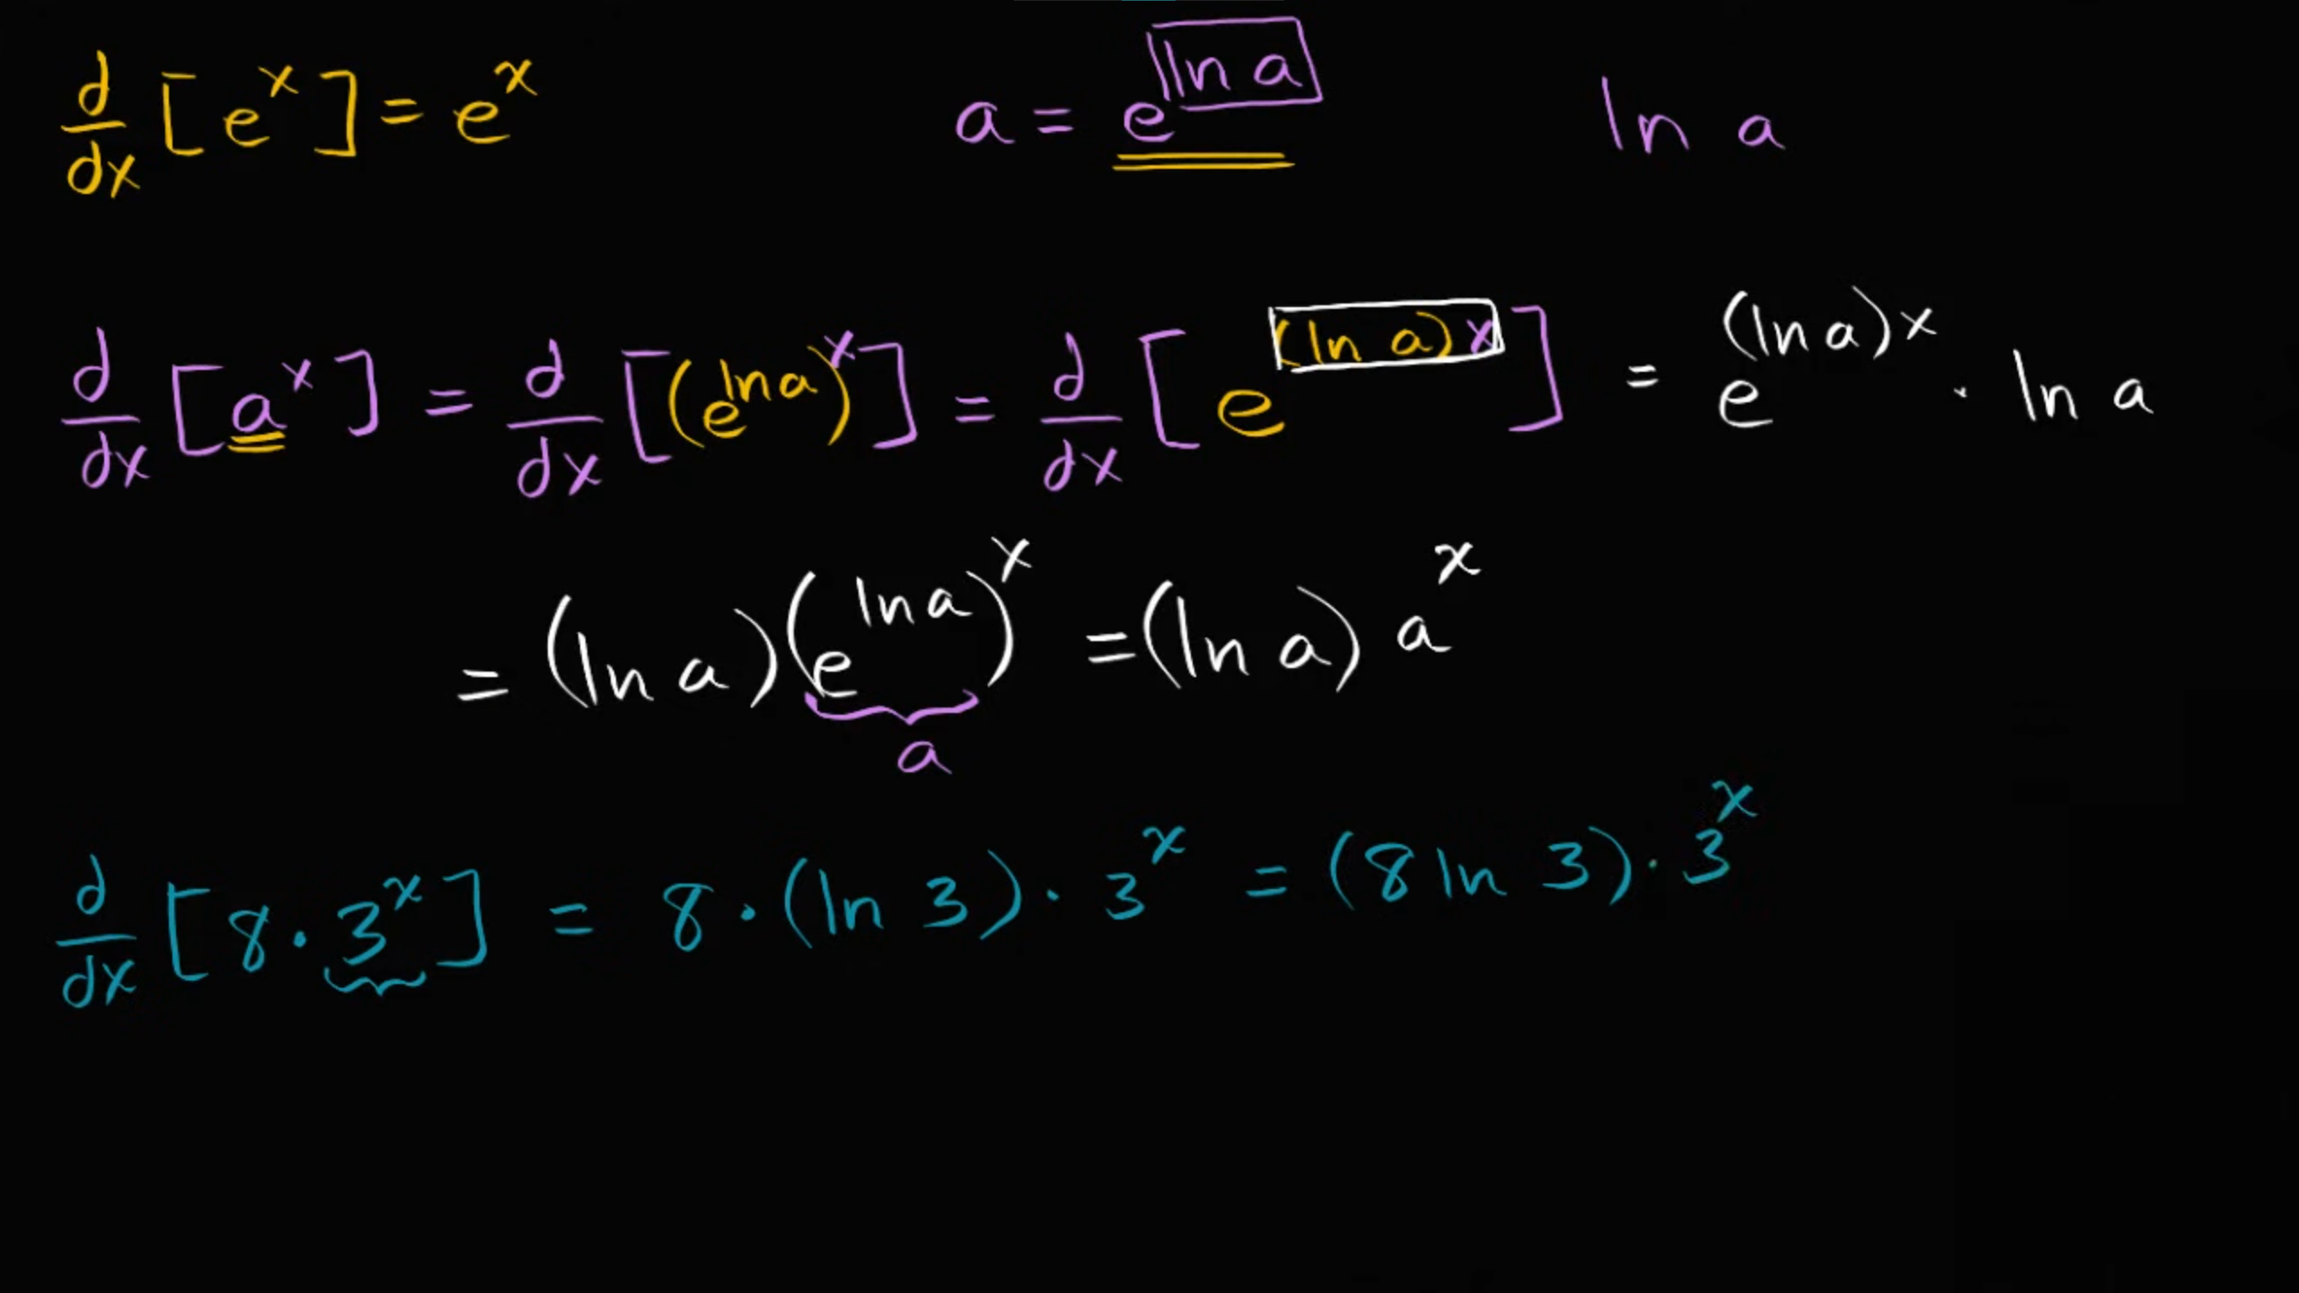

**Derivative of logₐx (for any positive base a≠1)**

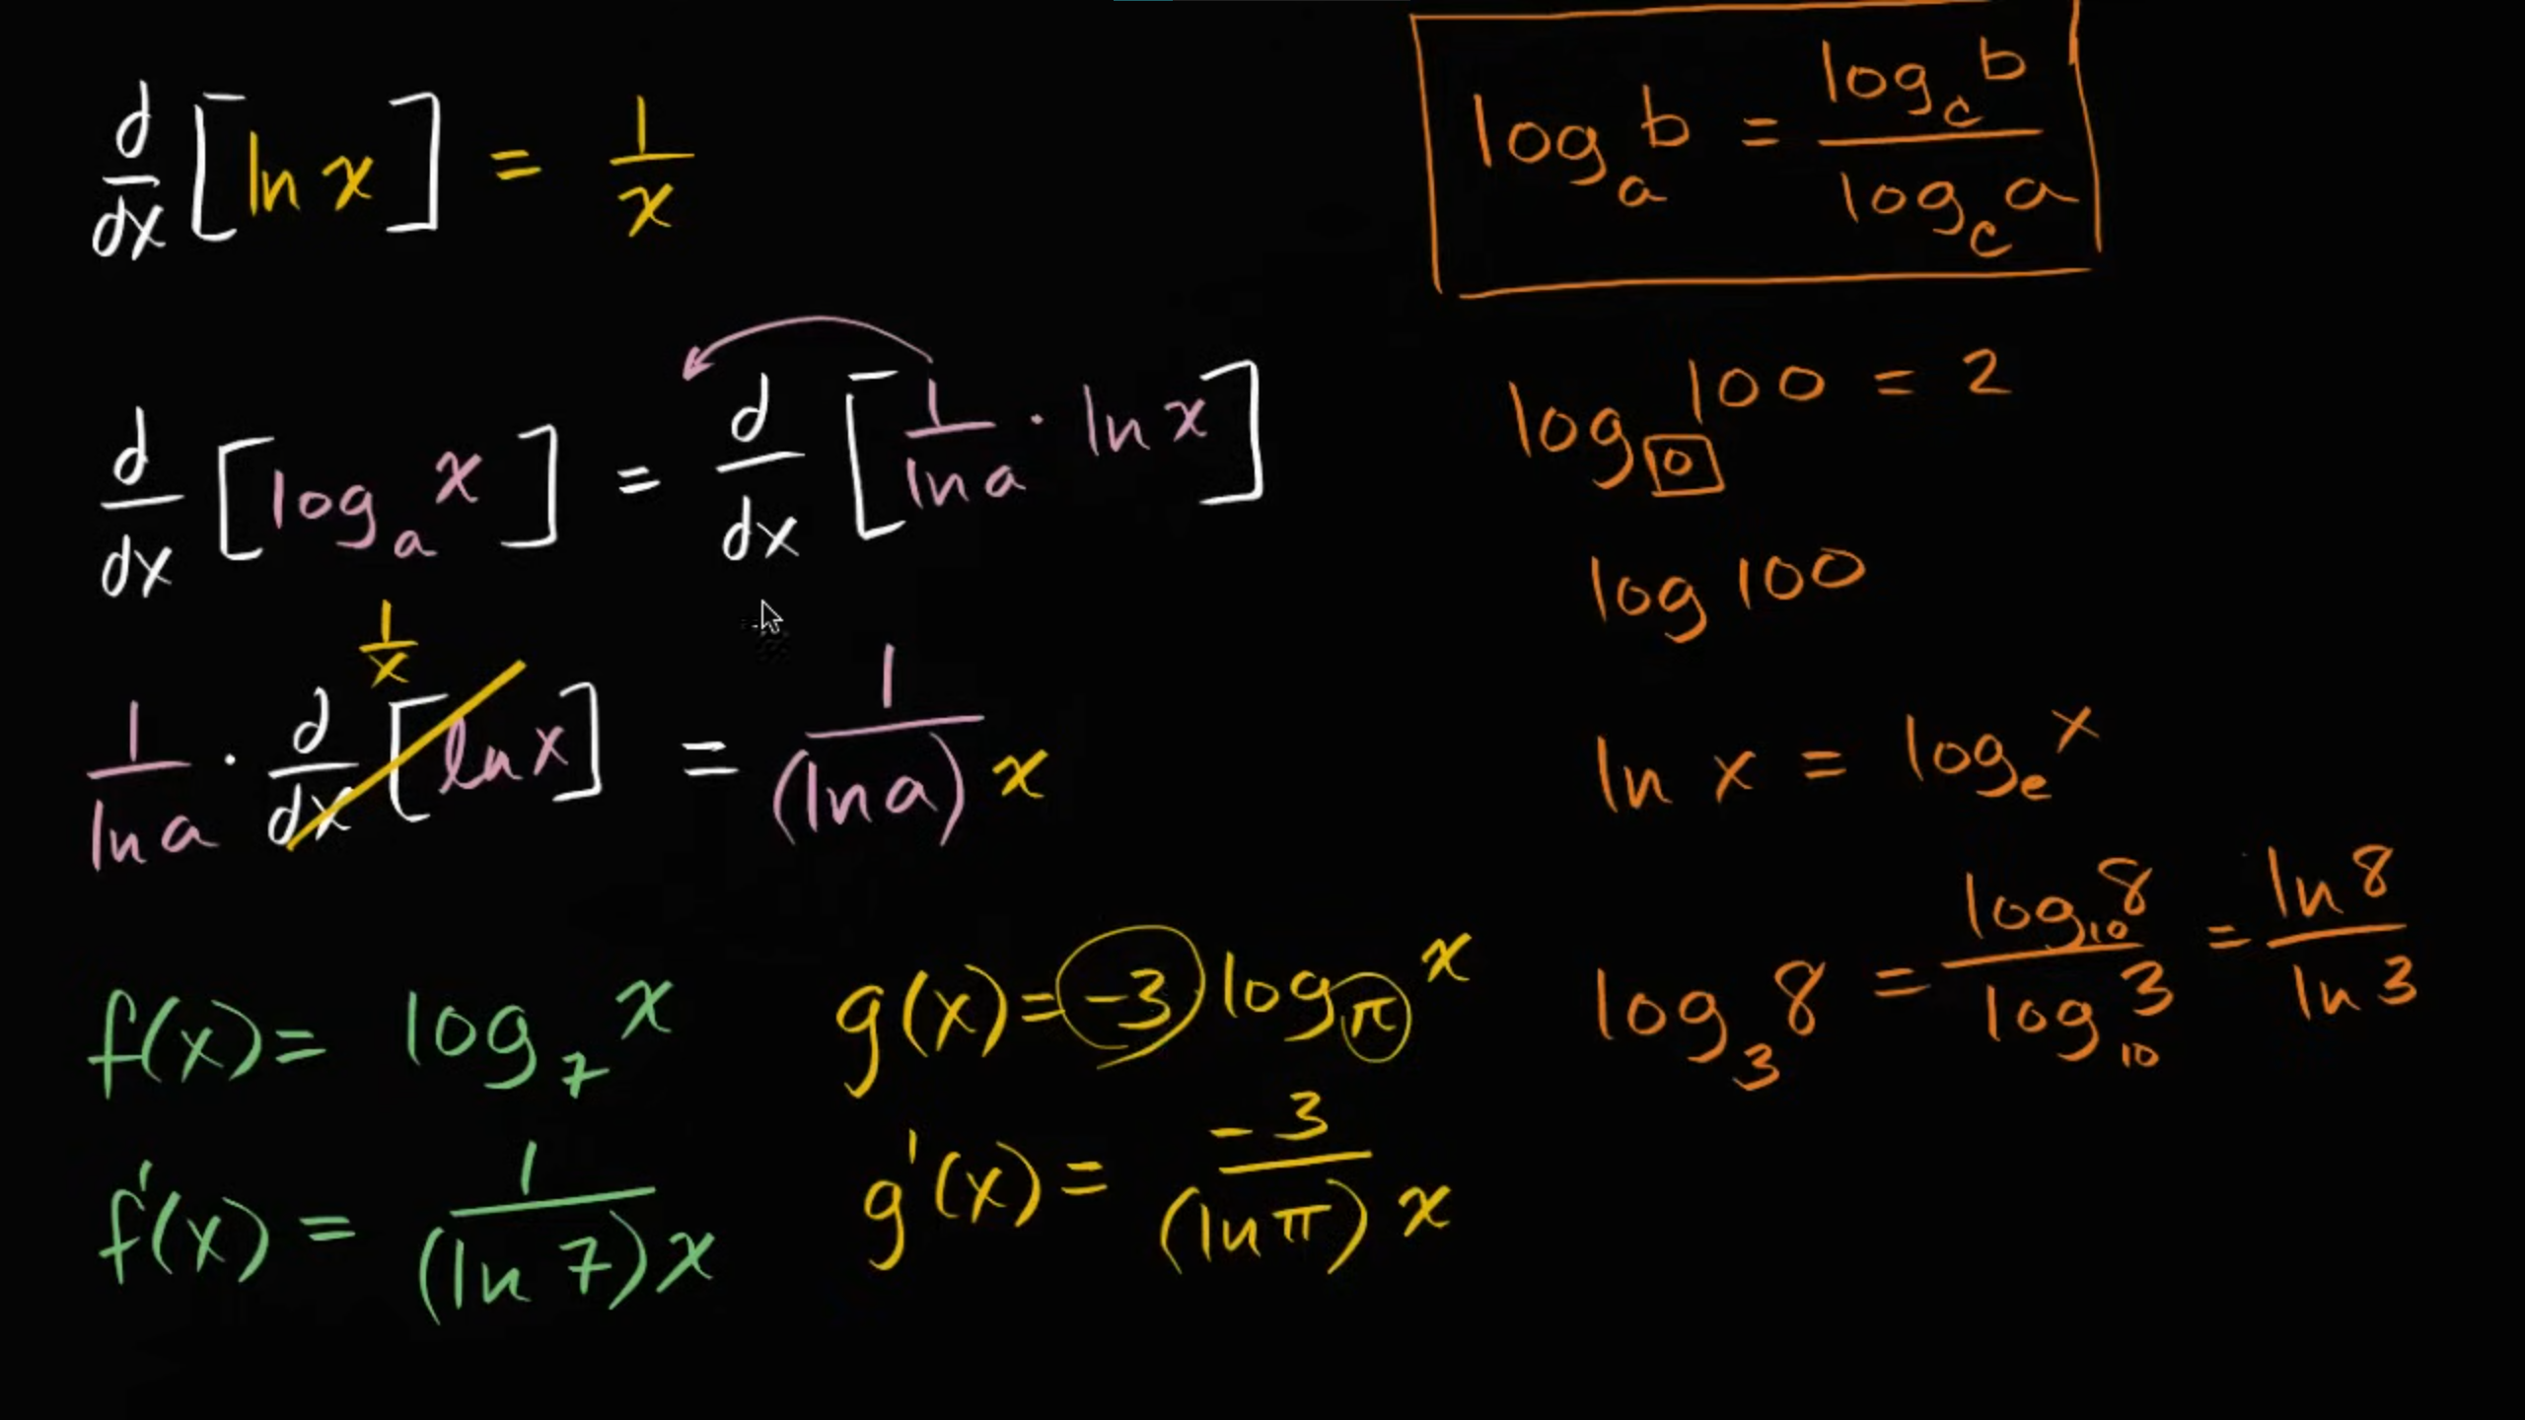

**Worked example: Derivative of 7^(x²-x) using the chain rule**

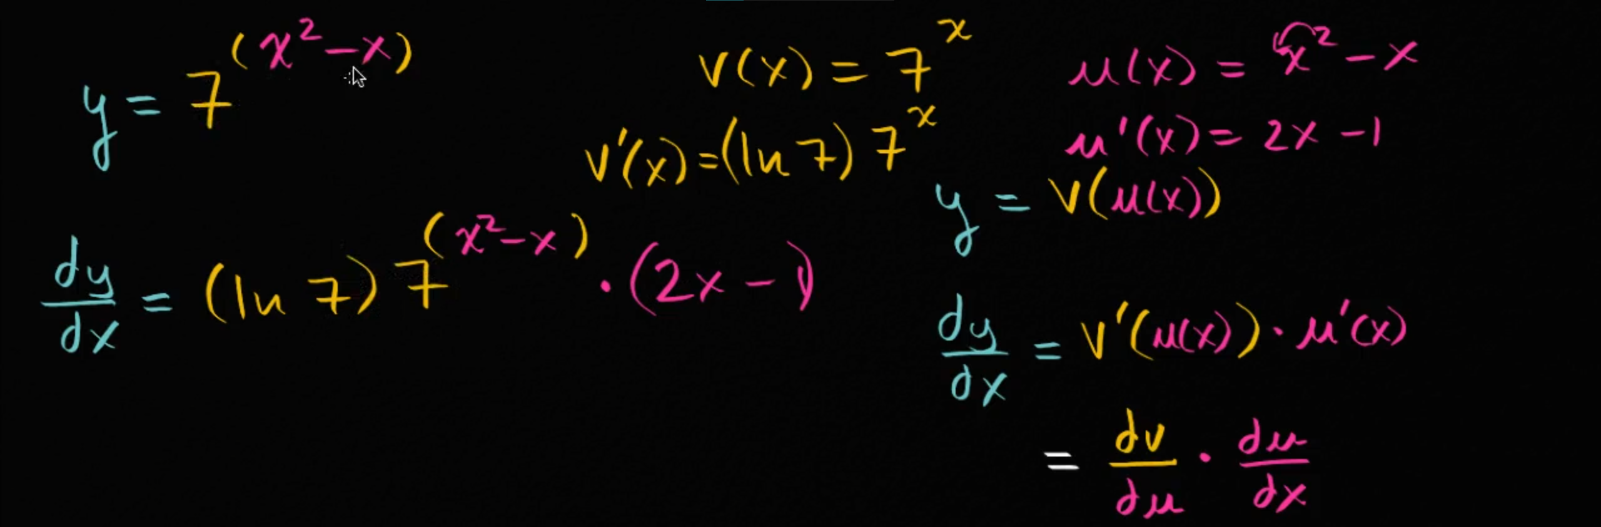

**Worked example: Derivative of log₄(x²+x) using the chain rule**

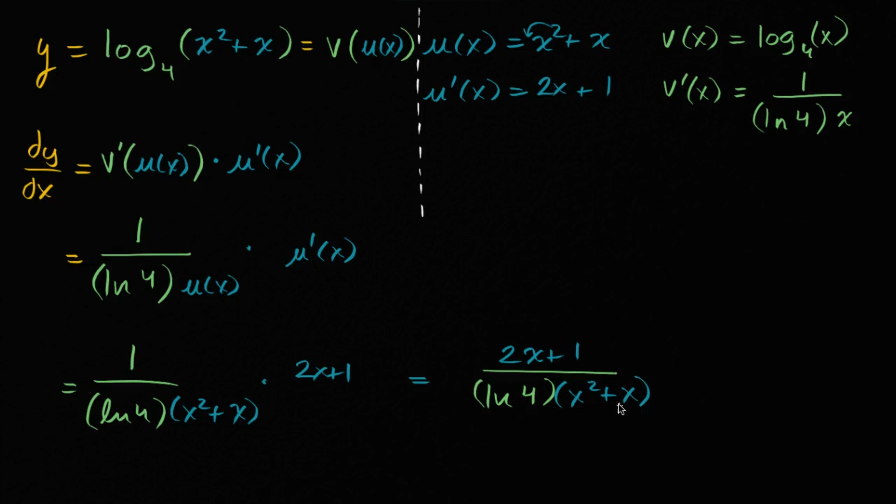

**Worked example: Derivative of sec(3π/2-x) using the chain rule**

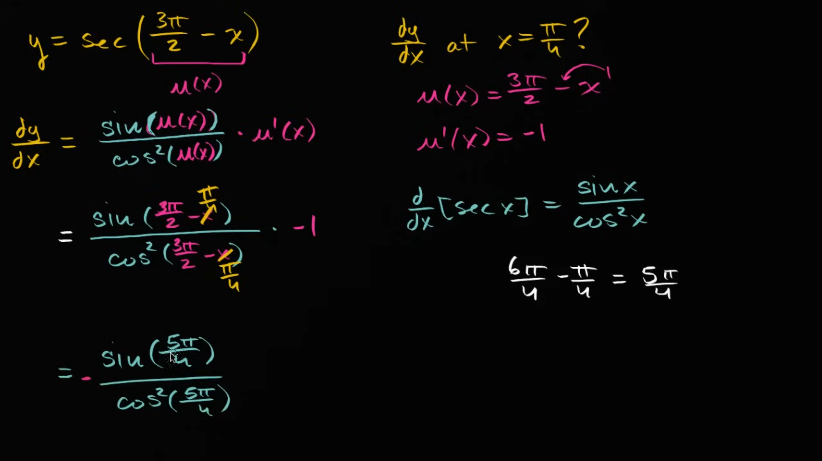

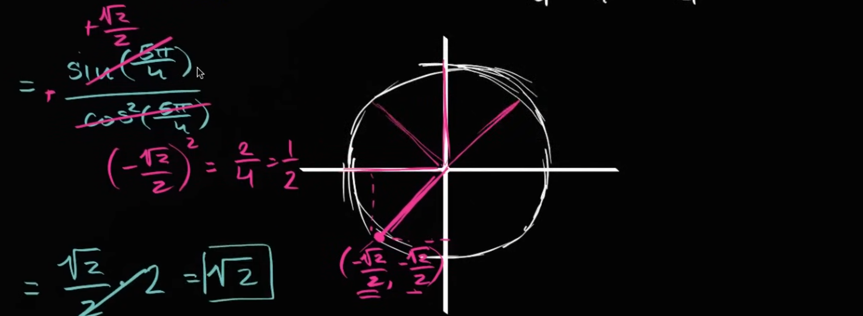

**Worked example: Derivative of ∜(x³+4x²+7) using the chain rule**

